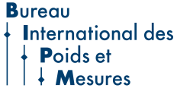

发布说明

计量顺时代之需，应民生之盼

**发布说明:**

5月20日是世界计量日，是1875年在巴黎签署《米制公约》的周年纪念日。这一公约为建立全球协调一致的测量体系奠定了基础，为科学发现与创新、工业制造、国际贸易，乃至生活质量提升和全球环境保护提供支撑。

2025年世界计量日的主题是“计量顺时代之需，应民生之盼”，选择这一主题，是为了突出计量在塑造人类过去、现在与未来中的的重要作用。这一主题在2025年更具特殊意义，因为恰逢《米制公约》签署150周年。

为了纪念这一里程碑，2025年世界计量日将是庆祝一个半世纪以来计量国际协作的核心活动。从确保公平贸易到推动科学发现再到应对气候变化和公共健康等全球性挑战，计量始终是进步与创新的基石。今年的主题还强调了包容性，认可可靠且可溯源的计量是促进平等和提升全人类生活质量的必要保障。

纵观全球，各国国家计量院致力于通过开发和验证各种复杂尖端的新测量技术，持续推动测量科学进步。同时，积极参加国际米制公约组织（BIPM）或区域计量组织开展的测量比对，以确保全球测量结果的可靠。

国际法制计量组织（OIML）制定“国际建议”，旨在实现多领域相关要求的全球一致性和协调性，并通过实施国际法制计量组织证书互认制度（OIML-CS），促进法制管理的计量器具的国际互认和全球贸易。

这些国际计量体系为测量的准确性提供了必要的保证和信心，为当今的全球贸易奠定了坚实基础，并帮助我们为应对未来挑战做好准备。

世界计量日旨在肯定和颂扬所有工作在国际、区域和国家计量机构中的人们一年来为计量所作的贡献。2023年11月，联合国教科文组织（UNESCO）第42届大会正式承认每年5月20日的世界计量日庆祝活动，这是一个重要里程碑。这一认可强调了计量在推动全球科学合作中发挥的关键作用，为促进计量发展开辟了新的途径，并与联合国教科文组织“通过科学和教育建设更美好世界”的使命相吻合。

更多信息，包括局长致辞、海报及庆祝活动，请访问

www.worldmetrologyday.org

联系方式：[wmd@worldmetrologyday.org](mailto:wmd@worldmetrologyday.org)

***编者按：***

世界计量日是一个年度性的活动，全世界在这一天庆祝计量对我们日常生活的影响。

1875年5月20日《米制公约》的签署，标志着全球计量领域合作的正式开启。这一天也因此被定为世界计量日，以表纪念。每年，**国际米制公约组织**（BIPM）和**国际法制计量组织**（OIML）均联合举办世界计量日活动，由各国国家计量机构参与。

国际计量界致力于确保全球测量结果的准确性，在每个世界计量日都以海报和网站的宣传形式提高大众对计量的认识。以往世界计量日的主题包括：计量与全球能源挑战，计量与安全，计量与创新，以及体育、环境、医学和贸易中的测量等。

**关于国际米制公约组织（BIPM）**

1875年《米制公约》的签署创建了BIPM，并正式开启了计量领域的国际合作。这一公约建立了国际米制公约组织，并为建立全方位的全球统一的测量奠定基础。历史上，计量重点关注和支持工业和贸易发展，但现在，它将应对气候变化、健康和能源等21世纪重大挑战，视为与工业和贸易发展同样至关重要。BIPM选取某些特定物理量和化学量开展最高水平的科学工作，同时也是由各国国家计量院（NMIs）联结而成的全球计量网络的中枢。各国国家计量院进一步将以SI为源头的计量溯源链传递给获认可的各国实验室以及工业界。

**关于国际法制计量组织（OIML）**

1955年，国际法制计量组织（OIML）成立。作为一个政府间组织，它致力于促进法制计量规则的全球统一，其秘书处和总部是国际法制计量局（BIML）。自成立以来，OIML建立了一个全球性的技术架构，目的在于协调各国国家计量部门或相关组织采用的计量法规和计量管理的一致。

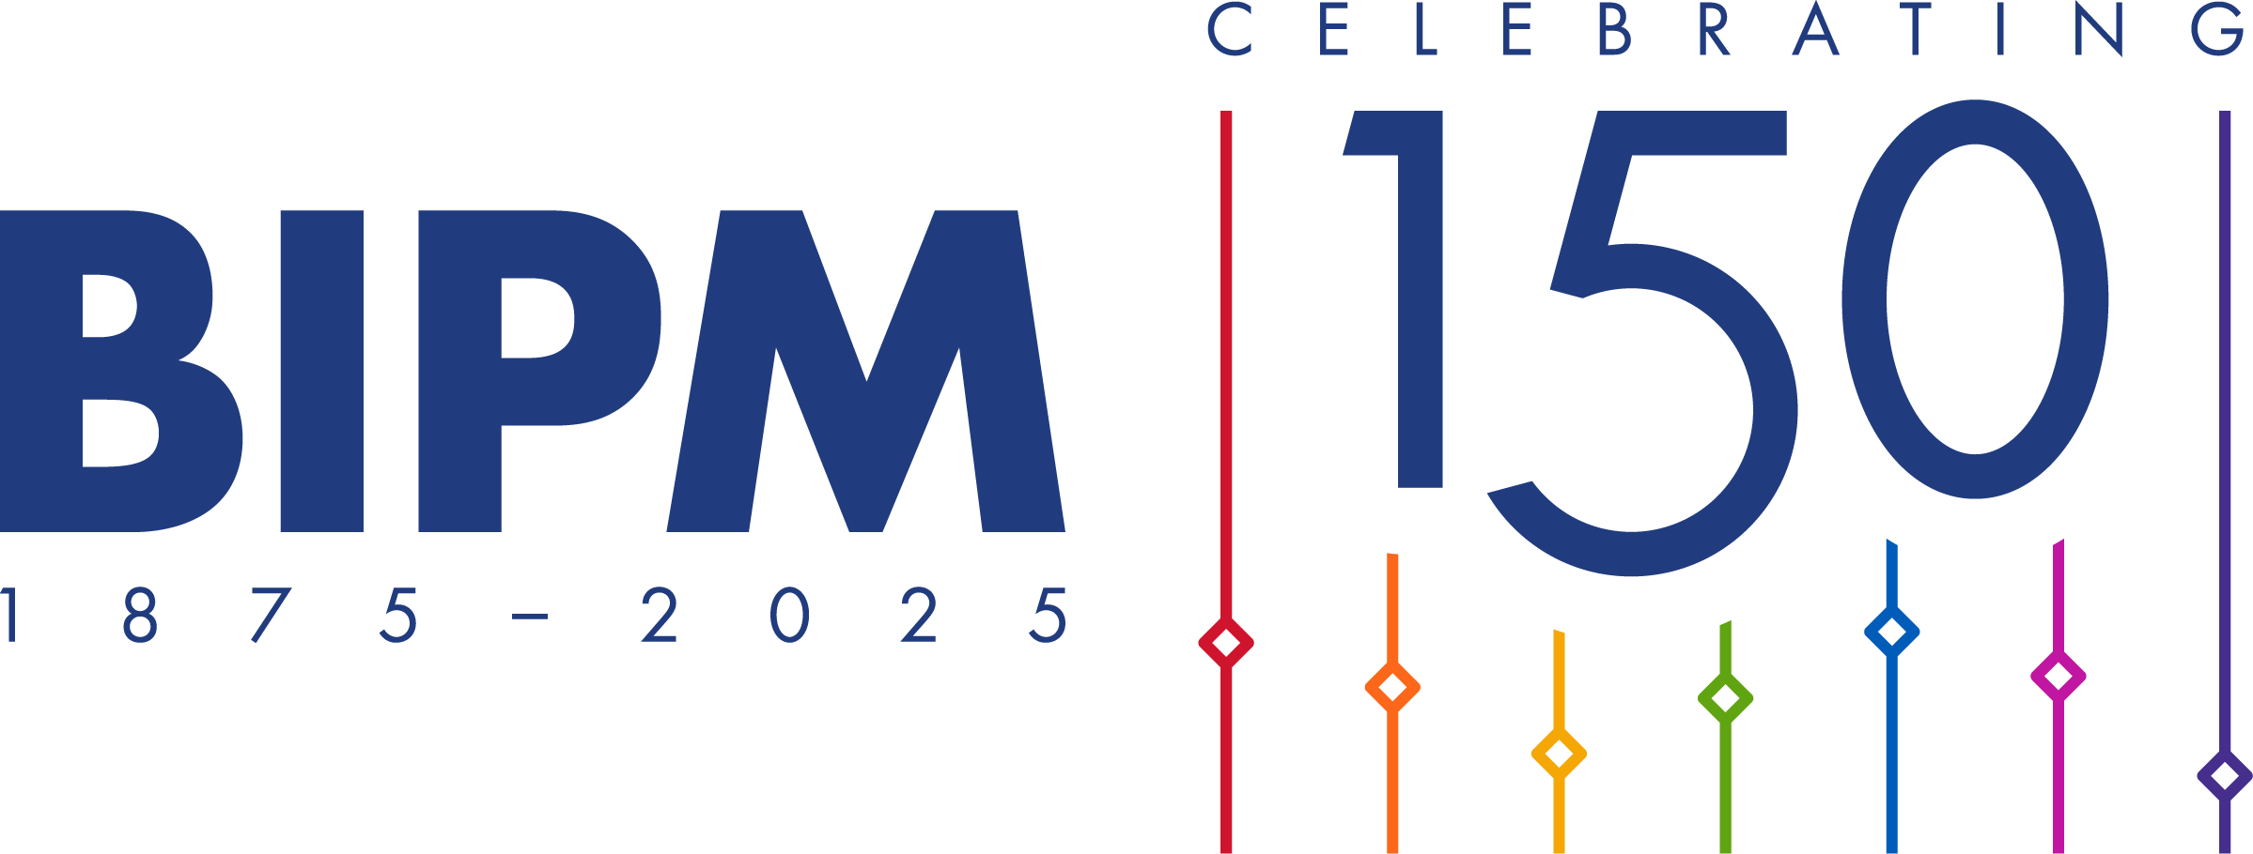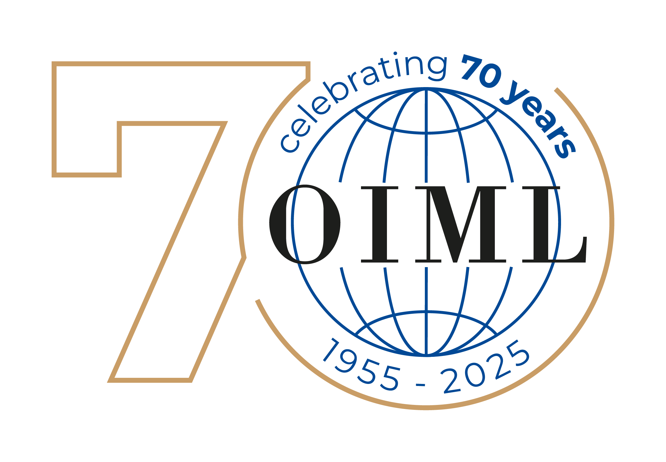

**Press release**

**WORLD METROLOGY DAY – 20 May 2025**

**Measurements for all times, for all people**

**Release:**

The 20 May is World Metrology Day, commemorating the anniversary of the signing of the *Metre Convention* in Paris, in 1875. This treaty provides the basis for a worldwide coherent measurement system that underpins scientific discovery and innovation, industrial manufacturing and international trade, as well as the improvement of the quality of life and the protection of the global environment.

The theme for World Metrology Day 2025 is ***Measurements for all times, for all people***, chosen to highlight the importance of measurements in shaping our past, present and future. This theme has added significance in 2025, which marks the 150th Anniversary of the Metre Convention.

As a tribute to this milestone, World Metrology Day 2025 will be at the core of events to celebrate a century and a half of international collaboration in metrology. From ensuring fair trade and advancing scientific discovery to addressing global challenges like climate change and public health, measurements have been fundamental for progress and innovation. The theme also emphasizes inclusivity, recognizing that reliable and traceable measurements are essential for fostering equity and improving the quality of life for all people, everywhere.

Around the world, national metrology laboratories continually advance measurement science by developing and validating new measurement techniques at the necessary level of sophistication. The national metrology institutes participate in measurement comparisons coordinated by the *Bureau International des Poids et Mesures* (BIPM) or by the Regional Metrology Organizations, to ensure the reliability of measurement results worldwide.

The *International Organization of Legal Metrology* (OIML) develops International Recommendations, which aim to align and harmonize requirements worldwide in many fields. The OIML also operates the OIML Certification System (OIML-CS) which facilitates international acceptance and global trade of regulated measuring instruments.

These international metrology systems provide the necessary assurance and confidence that measurements are accurate, providing a sound basis for global trade today and helping us to prepare for the challenges of tomorrow.

World Metrology Day acknowledges and honours the contributions of individuals working in intergovernmental, regional, and national metrology organizations and institutes year-round. In November 2023, a significant milestone was reached as the UNESCO General Conference, during its 42nd Session, officially recognized the celebration on 20 May annually. Underscoring its pivotal role in advancing global scientific cooperation, this endorsement opens up new avenues to promote metrology, aligning with UNESCO's mission to build a better world through science and education.

Further information, including a message from the Directors, posters,   
and a list of events, is available at   
[www.worldmetrologyday.org](https://www.worldmetrologyday.org) – Contact: [wmd@worldmetrologyday.org](mailto:wmd@worldmetrologyday.org)



***Notes for Editors:***

*World Metrology Day is an annual event during which the impact of measurement on our daily lives is celebrated around the world.*

*This date was chosen in recognition of the signing of the Metre Convention on 20 May 1875, the beginning of formal international collaboration in metrology. Each year World Metrology Day is organized and celebrated jointly by the* **[International Bureau of Weights and Measures](http://www.bipm.org)** *(BIPM) and the* **[International Organization of Legal Metrology](http://www.oiml.org)** *(OIML) with the participation of the national organizations responsible for metrology.*

*The international metrology community which works to ensure that accurate measurements can be made across the world endeavours to raise awareness each World Metrology Day through a poster campaign and* **[web site](http://www.worldmetrologyday.org)***. Previous themes have included topics such as measurements for the global energy challenge, for safety, for innovation, and measurements in sport, the environment, medicine and trade.*

***About the BIPM***

*The signing of the Metre Convention in 1875 created the International Bureau of Weights and Measures (BIPM) and for the first time formalized international cooperation in metrology. The Convention established the BIPM and laid the foundations for worldwide uniformity of measurement in all aspects of our endeavours, historically focusing on and assisting industry and trade, but today just as vital as we tackle the grand challenges of the 21st Century such as climate change, health, and energy. The BIPM undertakes scientific work at the highest level on a selected set of physical and chemical quantities. The BIPM is the hub of a worldwide network of national metrology institutes (NMIs) which continue to realize and disseminate the chain of traceability to [the SI](https://www.bipm.org/en/measurement-units/) into national accredited laboratories and industry.*

***About the OIML***

*In 1955 the International Organization of Legal Metrology (OIML) was established as an Intergovernmental Treaty Organization in order to promote the global harmonization of legal metrology procedures with the Bureau International de Métrologie Légale (BIML) as the Secretariat and Headquarters of the OIML. Since that time, the OIML has developed a worldwide technical structure whose primary aim is to harmonize the regulations and metrological controls applied by the national metrological services, or related organizations.*